GREY SWAN / ARCHIMEDES • v12.0-R1 • GLOBAL BASELINE • SEPTEMBER 2026

Where are we actually heading?
A short guide to what the model measures, the four futures it considers, and the latest global odds

The answer in plain English
The world is not collapsing. The economy is still growing, productivity is rising in many places, grids are adapting, AI is spreading and some governments are building real safeguards. But these advances are not moving together, and the gains are not being shared widely enough.
Grey Swan therefore judges the current global posture to be about 10% “Do The Right Thing” and 90% “Let It Rip”. Serious reform exists, but the dominant pattern is still faster deployment, uneven governance, concentrated capability and piecemeal adjustment.
What does that mean?
The most likely 2030 result is not sudden catastrophe. It is a world increasingly at risk of problems outrunning the capacity of institutions to manage them. Grey Swan calls that outcome Lost Control.

What is Grey Swan?
Grey Swan is a scenario model, not a crystal ball. It asks what happens when technological, economic, institutional and climate pressures interact, and whether leaders respond early and coherently or mostly allow events to run ahead of them.
It works with two broad policy postures. Do The Right Thing (DTR) means governments, firms and institutions make material, coordinated reforms. Let It Rip (LIR) means action stays fragmented, delayed or too weak to match the scale of change.

The four futures
Full Empowerment  Capability spreads widely, institutions stay resilient and the gains reach ordinary households, workers, firms and public services. | Managed Disruption  Serious shocks continue, but institutions usually cope. Gaps remain, yet the system broadly holds.
Uneven Transition  Some countries, sectors and groups advance while others stall. Gains are real, but patchy, brittle and politically difficult. | Lost Control  Not a Hollywood collapse. It means pressures increasingly outrun institutional capacity: inequality hardens, trust weakens, recovery slows and problems compound.

WHAT THE MODEL ACTUALLY MEASURES

Six levers, climate underneath them, and one final gate
Grey Swan does not judge the future from AI capability alone. It measures six practical systems. Climate change is treated as a pressure running through all six, and the Wealth-Diffusion Gate tests whether any gains are actually reaching ordinary people.
1. Energy and grids  Can societies deliver enough reliable, affordable power? The model looks at grid constraints, connection delays, adequacy, storage and resilience as demand rises. | 2. Health security and workforce  Can health systems detect threats early and keep working under pressure? It tracks surveillance, preparedness and the people needed to deliver care.

3. Education and skills  Are people actually being prepared for an AI-shaped economy? It looks at educator capability, meaningful AI use and whether learning systems are adapting rather than simply buying tools. | 4. Trust and information integrity  Can people trust the institutions and systems making important decisions? It looks at institutional effectiveness, corruption, political freedom, public trust, transparency, audit and whether automated decisions can be challenged.

5. Coordination and supply security  Can countries cooperate when shared systems are under stress? The model distinguishes real operational cooperation from declarations and also tracks whether trade and supply networks remain resilient. | 6. Compute and AI access  Who controls the productive layer of AI? It looks at concentration of advanced computing power and whether universities, smaller firms, public bodies and less powerful countries can gain meaningful access.

Climate change  Climate is not a seventh silo. It is the physical stress condition under the whole model: heat, water stress, food insecurity, migration, health burdens and infrastructure damage can weaken every other system. | Wealth-Diffusion Gate  This is the final test. Even if AI and productivity surge, the best outcome is blocked unless gains reach households and workers. The model checks financial resilience, labor’s share of income and whether inequality/shared prosperity is improving.

The model also checks whether the economic engine is working
Growth and productivity are measured explicitly. Grey Swan does not assume that strong growth automatically means success. It asks whether productive gains are broadening prosperity or simply concentrating wealth and power.

Why this is a systems model
The levers interact. Cheap AI without enough electricity is constrained. Better technology without education can deepen dependency. Strong productivity without wider income gains can increase political tension. Climate stress can overwhelm otherwise capable systems. Progress only counts as Full Empowerment when several systems move together and the Wealth-Diffusion Gate opens.

THE CURRENT GLOBAL OUTLOOK

What the probabilities say
The line graph shows how the model’s posture-weighted probabilities change across the three time horizons. These are disciplined scenario probabilities, not claims of scientific precision.
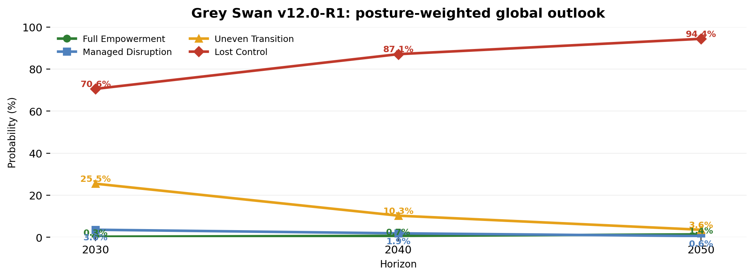
Current posture assumption: 10% DTR / 90% LIR. Reasonable sensitivity range for DTR: 7–15%.
How to read “Lost Control”
It does not mean civilisation ends. Economic growth may continue and AI may become extraordinarily capable. Lost Control means institutions increasingly struggle to absorb the pressures created by rapid change. Repeated shocks become harder to manage, inequality and concentration become embedded, and legitimacy weakens.

Why are the odds currently poor?
There are real positives: the global economy remains resilient, productivity is growing, major electricity systems are adapting, formal AI governance is beginning to operate in some jurisdictions and financial inclusion has improved. But advanced compute remains highly concentrated, education is adapting slowly, international cooperation lags the technology race, institutional trust is fragile, labor’s share of gains is weak, and the Wealth-Diffusion Gate remains closed.

Where does the evidence come from?
Grey Swan uses public-access, established and predominantly industry-standard or internationally recognised sources. Core v12 providers include the IMF, World Bank, ILOSTAT, OECD/OECD.AI, WHO, IEA and major grid operators, UNCTAD, Freedom House, Transparency International, public Gallup/OECD trust data, the Geopolitical Risk dataset and public Epoch AI compute estimates. Estimated rather than official sources are flagged and given less weight. No private telemetry or proprietary data are used.

What would change the odds?
The probabilities would improve if several systems begin moving together: more resilient grids; stronger health and education capability; enforceable AI governance; less concentrated productive compute; practical cross-border agreements; and clear evidence that households and workers are receiving a larger share of the gains.
The central message: the productive engine is still running, but the institutions responsible for steering, distributing and legitimising its gains are not moving at the same speed.

This is the non-technical brief. The v12.0-R1 Baseline and Transition Report and the v11.9→v12.0 Technical Change Note contain the full evidence architecture, source rules and audit trail.

